- The OASIS Website Staff

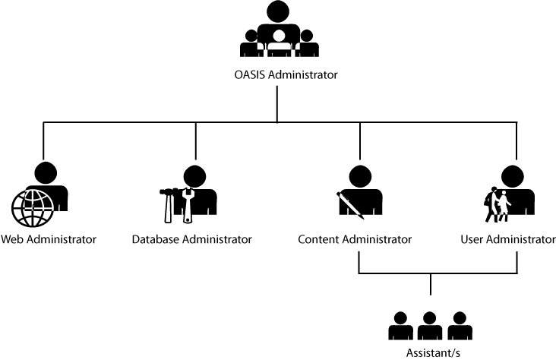
Figure 1 The OASIS Organizational Structure. The OASIS Administrator, being the head of the chart, oversees all the activities of the OASIS. The second level of the organization consists of the Web Administrator, Database Administrator, Content Administrator and the User Administrator. The only second-level administrators that will have assistants are the Content Administrator and the User Administrator.

- OASIS Administrator (OA)
- Creation of Account: The OA’s account is created by default and is hard-coded in the OASIS if it is the OASIS’ first deployment. There can only be one active account for the OA, thus, there can only be one OA at a time.
- Responsibilities: The OA will be in charge of the overall administration of the OASIS. Responsibilities will include the adding lower administrators, overseeing of activities done by the other administrators and purging of data.
- Access Privileges: OA has complete access to all functions of the OASIS which fully includes user accounts and also has the ability to create administrator accounts.
- Qualifications: The OA must already have administrative and supervisory experience in dealing with web services. The OA is preferably one who possesses comprehensive knowledge on web technologies and database systems.

- Web Administrator (WA)
- Creation of Accounts: Web Administrator will not have any account in the OASIS.
- Responsibilities: The WA will be in charge of administering the source code of the OASIS. It is the duty of the WA to maintain the website by changing, updating, or patching the code of the site.
- Access Privileges: The WA has complete access to the source code of the website. The WA can make changes to the code provided that the OA first authorizes the action that the WA will execute.
- Qualifications: The WA must have extensive knowledge on several web technologies, platforms, and web languages such as JavaScript, CSS, HTML, and most specially Ruby and RoR. The WA must also have experience on source code maintenance and administration.

- Database Administrator (DA)
- Creation of Account: Database Administrator will not have any accounts in the OASIS.
- Responsibilities: The DA will be in charge of administering the database of the OASIS. Responsibilities include managing, sanitizing, normalizing, and securing the data kept in the database.
- Access Privileges: The DA has complete access to the database. The DA can manage and make changes to the database provided that the OA must first authorize those actions.
- Qualifications: The DA must have extensive knowledge on several database systems such as mySQL, Oracle and preferably PostgreSQL. The DA must also have experience on database maintenance and data transfer.

- Content Administrator (CA)
- Creation of Account: Account is created by the OA. There may only be one active account for the Content Administrator, thus, there can only be one CA at a time.
- Responsibilities: The CA will be responsible for administering and controlling website data and content on the OASIS. The CA may also be seen as a data administrator. The CA is also responsible in importing the data that comes from the MIS and Accounting Offices.
- Access Privileges: The CA has complete access to the website content of the OASIS. The CA can edit and manage changes in the website contents provided that the OA must first authorize those actions.
- Qualifications: The CA must have ample skills in encoding, importing and transferring of data coming from an external source. The CA must have basic knowledge in XML.

- User Administrator (UA)
- Creation of Account: Account is created by the OA. There may only be one active account for the User Administrator, thus, there can only be one UA at a time.
- Responsibilities: The UA will be in charge of managing the accounts of users registered in the OASIS. Responsibilities include the maintenance of accounts, securing the accounts and management of accounts such as the banning by blocking or re-enabling by unblocking.
- Access Privileges: The UA has partial access to the user accounts of the users. The UA can help users who are having problems regarding the OASIS. The UA also has the authority to ban an account by blocking the user who abuses his or her account in any manner.
- Qualifications: The UA must have administrative and supervisory experience in dealing with people. The UA also must extensively know the policies and terms and conditions made by the OASIS.

- Assistants
- Creation of Account: Assistants will not have any accounts in the OASIS.
- Responsibilities: The assistants will be responsible for tasks that will be assigned to them by the CA and the UA regarding the OASIS, such as generation handling and mailing of verification letters.
- Access Privileges: The assistants do not have access to any part of the OASIS administrator interfaces, the database nor the web source code.
- Qualifications: Assistants must be at least college level, of legal age and computer-literate.

